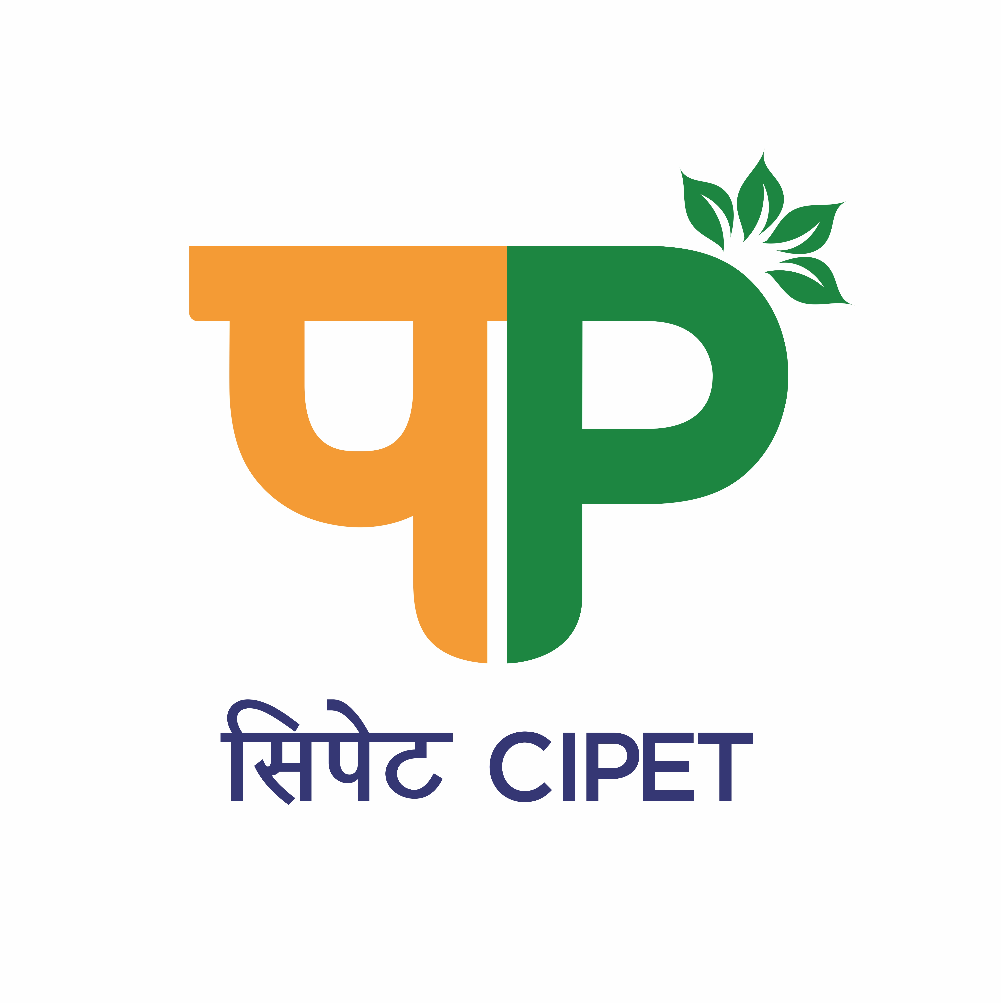
CENTRAL INSTITUTE OF PETROCHEMICALS ENGINEERING & TECHNOLOGY (CIPET)
SCHOOL FOR ADVANCED RESEARCH IN PETROCHEMICALS (SARP)
सिपेट:एसएआरपी-एलएआरपीएम, भुवनेश्वर
(Department of Chemicals & Petrochemicals, Ministry of Chemicals & Fertilizers, Govt. of India)
B-25, C.N.I. Complex, Patia, Bhubaneswar – 751 024 (Odisha)
Tel: 0674-2740173/2742852, Fax: 0674-2740463
Email: larpm@cipet.gov.in, Website: www.cipet.gov.in

CIPET:SARP-LARPM/Recruit-CTEF-INNOV./2024-25/04 19.12.2024
CALL FOR APPLICATIONS FOR BUSINESS MANAGER
CIPET: SARP-LARPM, Bhubaneswar invites young and dynamic young professionals for the following positions to work under the CTEF-INNOVEX Cell:-

Name of the Post(s) | No. of Positions | Qualification | Fellowship
Business Manager | 01 | - Full time MBA in Marketing / Finance from a recognized University.  - Minimum 03 years of post qualification experience in handling project related or similar work in the field of Strategic thinking, Research Skill on Project Management, Creativity, Knowledge of standups/startups in Incubation cell.  Essential Skill Sets:  - Experience in Project Management and Planning.  - Should have excellent Oral and Written communication skills.  - Should possess excellent skills in Marketing, Leadership, Problem Solving, Revenue Generation and Creativity. | As per Institute norms / guidelines

How to Apply: The candidates having the desired qualification & experience may apply with all relevant documents to “The Officer(P&A/HR), CIPET:SARP-LARPM, B-25, CNI Complex, Patia, Bhubaneswar-751024, Odisha” by e-mail to larpmadmn@cipet.gov.in on or before 03.01.2025(Friday) till 12.00 midnight.
Duration of Project: The position is purely temporary and initially only for a period of 01 (one) year but extendable based on the requirement as well as performance of the individual.

The Application Form, essential qualification & other details can be downloaded from www.cipet.gov.in.
CIPET:SARP-LARPM, Bhubaneswar reserves the right to increase/decrease/cancel any or all the posts without assigning any reasons thereof.

Officer(P&A/HR)

Terms and Conditions:

- The contract is purely temporary and initially only for a period of 01(one) year but extendable depending on the project need as well as performance of the candidate.

- The Candidate has to fully devote their time for the project work and are not allowed to join any other course (Part/ Full time).

- The Upper Age Limit as on 03.01.2025 for the post of Business Manager shall be 35 years.

- Age relaxation for SC/ST/OBC and women candidates will be extended as per DST rules and 230(17) of GFR 2017 concerning reservation of SC/ST/OBC, if applicable.

- Selection will be made purely as per the Institute guidelines.

- No TA/DA will be paid for either attending the interview or while joining the project.

- Original documents of Certificates / Degrees / Mark sheets / Age-Proof / and other Testimonials should be produced at the time of Interview.

- Shortlisted candidates will be called for the Written Test/Interview either in person/online and the date of Interview will be intimated via e-mail only. No other communication in this regard will be entertained.

- If the Applicant fails to submit the required documents/incomplete applications shall be rejected.

- If any candidate is found guilty of providing false information in due course after selection/joining, then necessary action shall be taken against the candidate and he/she shall have to refund all the payments made to him/her during the said tenure.

Officer(P&A/HR)

