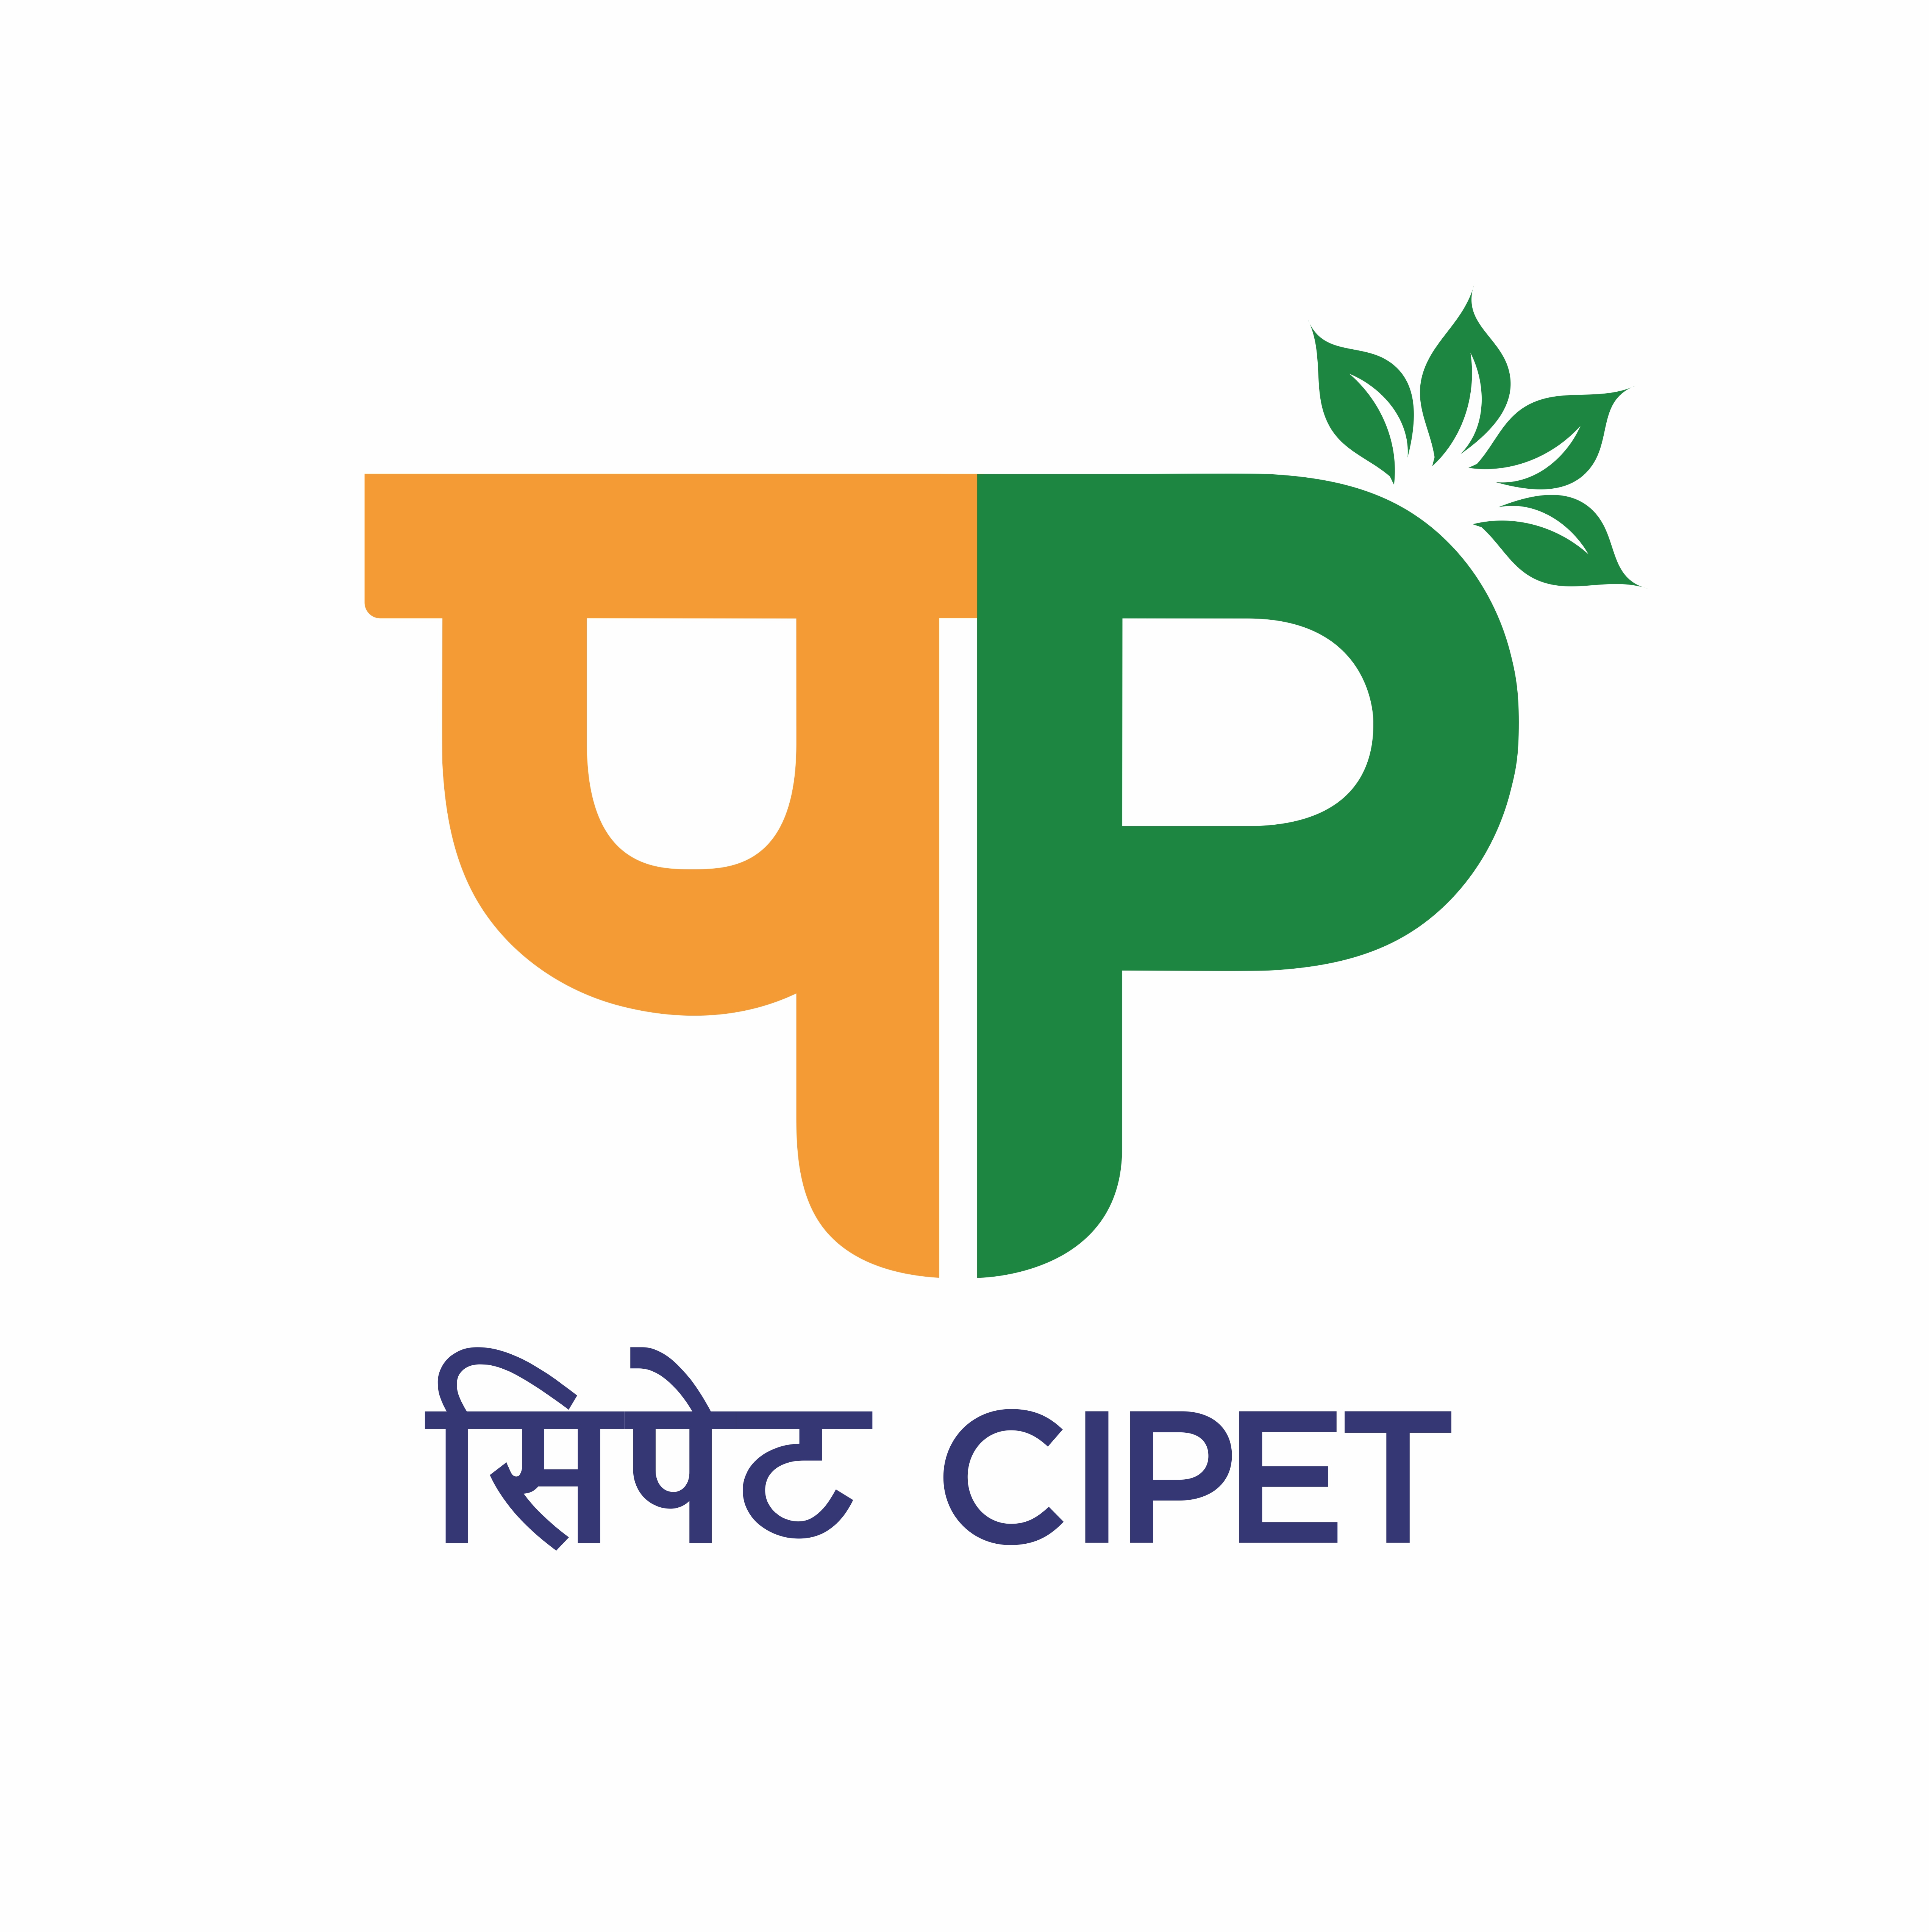
CENTRAL INSTITUTE OF PETROCHEMICALS ENGINEERING & TECHNOLOGY (CIPET)
SCHOOL FOR ADVANCED RESEARCH IN PETROCHEMICALS (SARP)
सिपेट:एसएआरपी-एलएआरपीएम, भुवनेश्वर
(Department of Chemicals & Petrochemicals,
Ministry of Chemicals & Fertilizers, Govt. of India)
B-25, C.N.I. Complex, Patia, Bhubaneswar – 751 024 (Odisha)
Tel: 0674-2740173/2742852, Fax: 0674-2740463
Email: larpm@cipet.gov.in, Website : www.cipet.gov.in

CIPET:SARP-LARPM/Recruit.-WI/2024-25/02 25.07.2024
WALK-IN-INTERVIEW FOR RESEARCH PERSONNELS
CIPET: SARP-LARPM, Bhubaneswar invites young and dynamic Research Personnels for the following positions to work under various sponsored projects :-

Name of the Post(s) | Qualification | Fellowship
Project Analytical Staff | - M.Sc / M.Tech in Polymer Science / Physics/Chemistry/Plastics Engineering/ Material Science & Engineering/ PNT/ Polymer Nanotechnology with 03 years of experience in Analysis and Characterization of High End Analytic Equipment’s.  - Candidates having Higher Qualification with GATE/NET score shall be preferred. | As per Institute norms /guidelines
Field Assistant | - B.Sc. & PGD-PPT(from CIPET) with 01 year experience in relevant field. Candidates having Higher Qualification shall be preferred. | As per Institute norms /guidelines

How to Apply: The candidates having the desired qualification & experience may walk-in for interview with all relevant original documents, one set of photocopies of all certificates alongwith duly filled in application form on 06.08.2024(Tuesday) at 11.00 A.M at CIPET:SARP-LARPM, B-25, C.N.I. Complex, Patia, Bhubaneswar – 751 024, Odisha.
Duration of Contract: The position is purely temporary and initially for a period of 01 (one) year.

The Application Form, essential qualification & other details can be downloaded from www.cipet.gov.in.
CIPET:SARP-LARPM, Bhubaneswar reserves the right to cancel any or all the post without assigning any reasons thereof.

Officer(P&A/HR)

Terms and Conditions:

- The position is purely temporary and initially for a period of 01 (one) year.

- The Candidate(s) have to fully devote their time for the project work and are not allowed to join any other course (Part/ Full time).

- Selection will be made purely as per the Institute guidelines.

- No TA/DA will be paid for either attending the interview or while joining the project.

- Original documents of Certificates / Degrees / Mark sheets / Age-Proof / and other Testimonials should be produced at the time of Walk-in-Interview.

- If any false information is provided by the candidate(s) and is found guilty, necessary action will be taken and the candidate has to refund all the payments made to him/her.

Officer(P&A/HR)

